# CSE 6010

**Assignment 1 Wenxiang Lei**

**Report**

I use seven different function to create the forest-fire simulation.

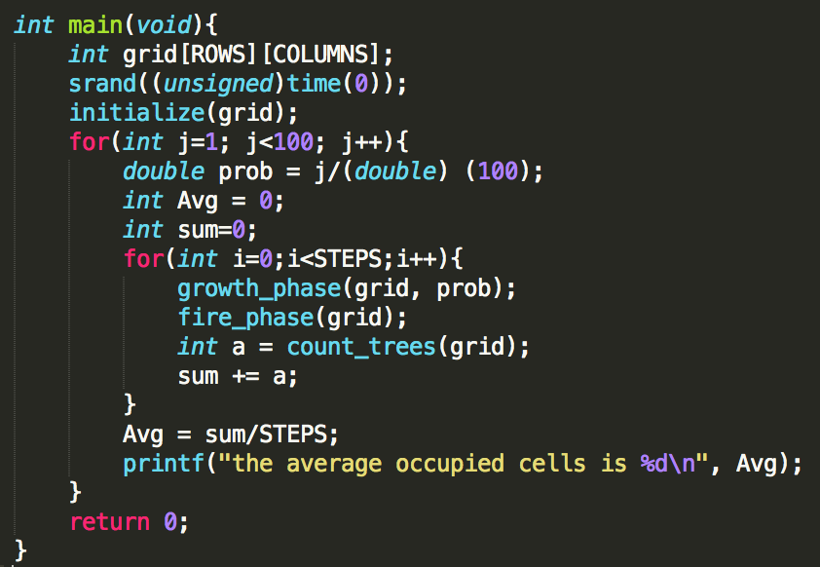

In the main function, at first, I create a 2-D arrays

“grid[ROWS][COLUMNS]” which ROWS & COLUMNS are defined using #define, you can change the value easily. I use 100 for rows and 100 for columns to make 100*100 grid as assignment required.

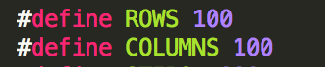

Then use srand() function to set the seed to be used by the random generator algorithm. The initialize() function use to set every cells in grid to be 0. In the outer for loop, the prob is equal to growth probability g and it chose from 0.01 to 0.99.

In the inner for loop, the STEPS means the maximum time step, I set it to 1000. At each time step, run growth_phase function then run fire_phase function, then get the occupied cells and calculate the average occupied cells after all the time steps.

Here is the partial result I obtained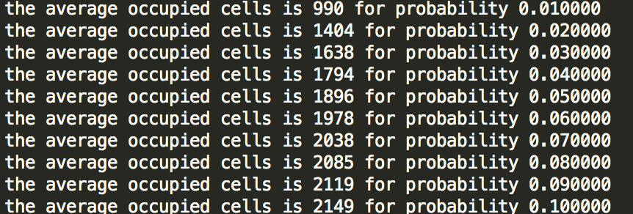

After I plug lightning strike probability f = 0.01, 0.02, 0.05, I get the result and create a graph.

From this graph we can find out, the average occupied cells in different f has the same trend. It goes up initially, then when growth rate(g) at 0.15 it reaches the apex, after that it goes down. For the lightning strike probability(f), obviously, with larger f the cell with tree would more likely to be burn. Thus the graph shows in that way. For g, my speculation is with larger g, after growth phase it would definitely have more cells with tree, it means more tree cells would be connected. In fire spread phase, more tree cells connected means if one of the cell fire it could make all connected cells to be 0.That’s why when g become larger then the number of average occupied cell drop.

**Literature Review**

Analytical solutions using standard mathematical methods are always a preferred approach, but when their application is not possible, as is almost always the case when working with complex systems (White and Ingalls 2009), simulation is arguably the most robust method applied to model real life stochastic systems that evolve probabilistically over time (Minas, Hearne, and Handmer 2012).

In the simulation, we suppose 100×100 square lattice and the initial condition where all the cell is 0. Comparing my analytical result to their result, the value of average occupied cells seems to be similar when g is below 0.15. In contrast, when g is above 0.15, there is an discrepancy by around 20 between the values of average occupied cells(Sang Il Pak and Tomohisa Hayakawa.2011). This maybe when g is small, the probability of a cell with tree is also small, then the number with cell occupied would be small. When the cell number small, most of cells would not connected, thus my result is very identical to their result, vice versa.

**Reference**

White, K. P., and R. G. Ingalls. 2009. Introduction to simulation. Paper read at Simulation Conference (WSC), Proceedings of the 2009 Winter, 13-16 Dec. 2009.

Minas, James P., John W. Hearne, and John W. Handmer. 2012. "A review of operations research methods applicable to wildfire management." International Journal of Wildland Fire no. 21 (3):189-196. doi: http://dx.doi.org/10.1071/WF10129.

Sang Il Pak and Tomohisa Hayakawa.2011. Forest Fire Modeling Using Cellular Automata and Percolation Threshold Analysis. 2011 American Control Conference

A. L. Sullivan, “A review of wildland fire spread modeling, 1990–present 3: Mathematical analogues and simulation models,” Int. J. Wildland Fire, vol. 18, pp. 387– 403, 2008.